|  |
| --- |
| SRI RAMACHNADRA ENGINEERING & TECHNOLOGY  **OPEARTING SYSTEMS**  31/08/2020  **M.SATHISHKUMAR**  **E0119052**  **CSE - 150**  Report on Linux Commands |

# COMMAND 1

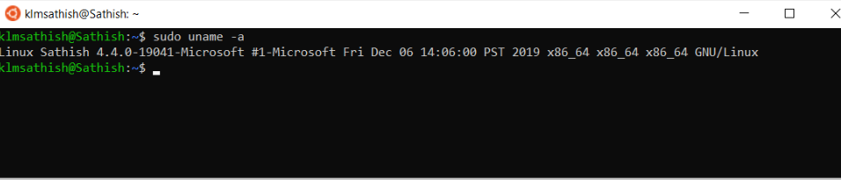

**Uname -a**

**Uname command is used in Linux to find operating systems information. Uname had many options that can provide kernel name, kernel version, CPU type and hostname.**

SRET

Report on Linux Commands

31/08/2020

### SRi RAMACHANDRA

### ENGINEERINg &

### TEchnology

## OPERATING SYSTEMS

# COMMAND 2

SRET

31/08/2020

Report on Linux Commands

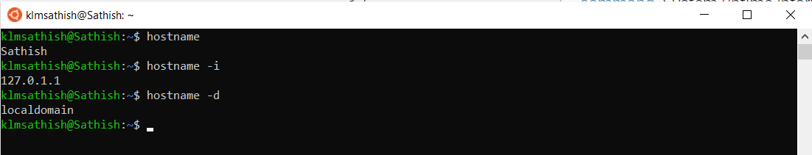

**hostname**

**You can display your machine hostname by typing hostname in your terminal. With -i option you can view the ip address of the machine and with -d you can view the domain name.**

**From the following command we can understand that the system is up and running for the last 13 mins.**

### SRi RAMACHANDRA

### ENGINEERINg &

### TEchnology

## OPERATING SYSTEMS

### SRi RAMACHANDRA

### ENGINEERINg &

### TEchnology

## OPERATING SYSTEMS

# COMMAND 3

**date**

**In Linux, date command is used to check the current date and time of the system. This command allows you to set custom formats for dates.**

**As an example, by using 'date +%D' you can view the date in 'MM/DD/YY' format.**

SRET

31/08/2020

Report on Linux Commands

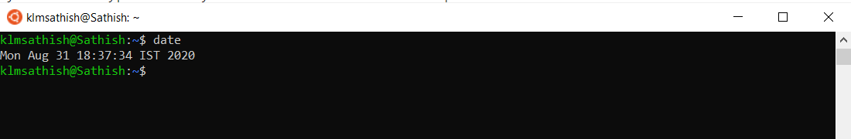

### SRi RAMACHANDRA

### ENGINEERINg &

### TEchnology

## OPERATING SYSTEMS

# COMMAND 4

SRET

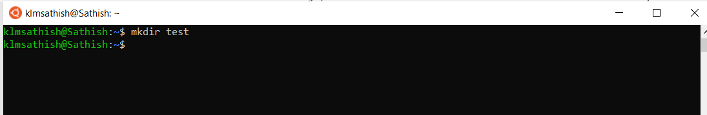

**mkdir**

**Use the mkdir command when you need to create a folder or a directory. if you want to create a directory named “test”, then you can type - “mkdir test”**

Report on Linux Commands

31/08/2020

### SRi RAMACHANDRA

### ENGINEERINg &

### TEchnology

## OPERATING SYSTEMS

# COMMAND 5

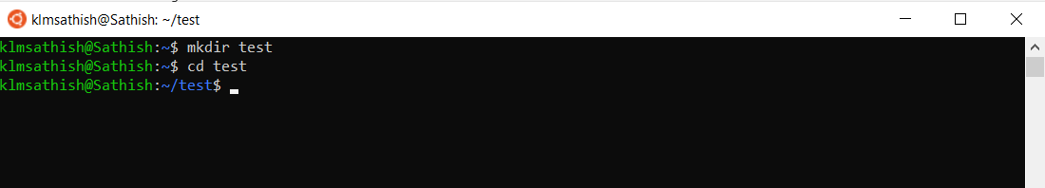

SRET

31/08/2020

Report on Linux Commands

**cd**

**Use the "cd" command to go to a directory. For example, if you are in the home folder, and you want to go to the test folder, then you can type in “cd test”. Remember, this command is case sensitive, and you have to type in the name of the folder exactly as it is.**

### SRi RAMACHANDRA

### ENGINEERINg &

### TEchnology

## OPERATING SYSTEMS

# COMMAND 6

**touch**

**The touch command is used to create a file. It can be anything, from an empty txt file to an empty zip file. For example, “touch new.txt”.**

SRET

31/08/2020

Report on Linux Commands

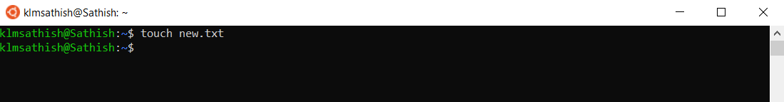

### SRi RAMACHANDRA

### ENGINEERINg &

### TEchnology

## OPERATING SYSTEMS

# COMMAND 7

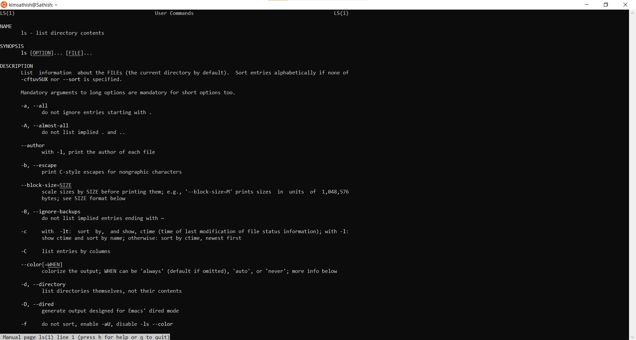

SRET

31/08/2020

Report on Linux Commands

**man**

**To know more about a command and how to use it, use the man command. It shows the manual pages of the command. For example, “man ls” shows the manual pages of the cd command.**

### SRi RAMACHANDRA

### ENGINEERINg &

### TEchnology

## OPERATING SYSTEMS

# COMMAND 8

31/08/2020

Report on Linux Commands

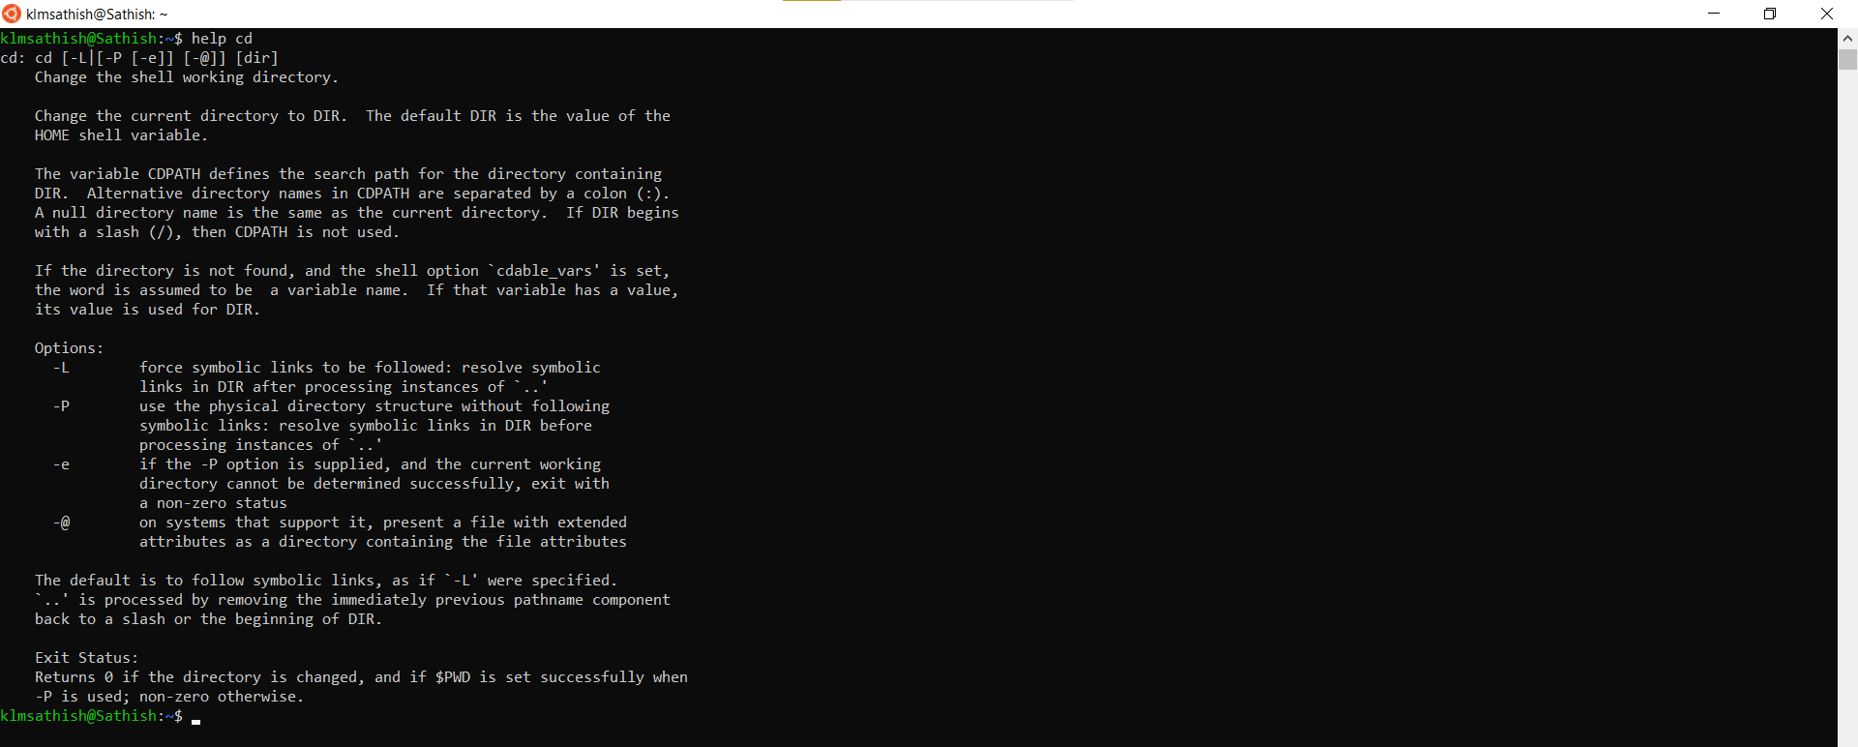

**help**

**Typing in the command name and the argument helps it show which ways the command can be used (e.g. help cd)**

SRET

# COMMAND 9

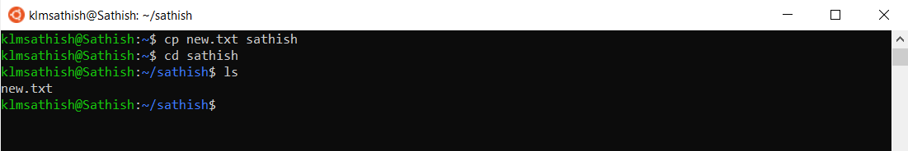

SRET

**cp**

**Use the cp command to copy files through the command line. It takes two arguments: The first is the location of the file to be copied, the second is where to copy.**

**\*Checking in directory sathish**

**Checking in directory sathish**

Report on Linux Commands

31/08/2020

### SRi RAMACHANDRA

### ENGINEERINg &

### TEchnology

## OPERATING SYSTEMS

# COMMAND 10

SRET

31/08/2020

Report on Linux Commands

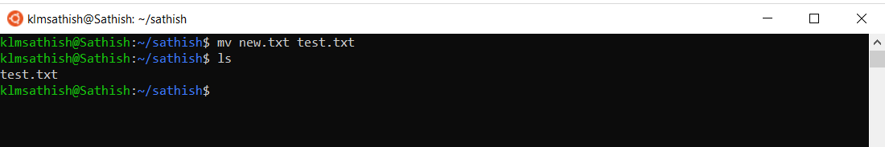

**mv**

**We use the mv command to rename a file. For example, if we want to rename the file “new.txt” to “test.txt”, we can use “mv new.txt test.txt”.**

**From the following command we can understand that the system is up and running for the last 13 mins.**

### SRi RAMACHANDRA

### ENGINEERINg &

### TEchnology

## OPERATING SYSTEMS

### SRi RAMACHANDRA

### ENGINEERINg &

### TEchnology

## OPERATING SYSTEMS

# COMMAND 12

SRET

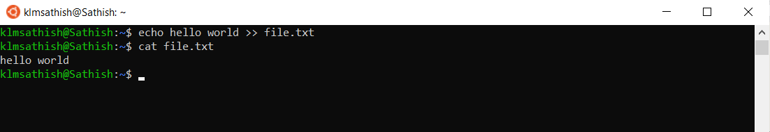

**cat — Use the cat command to display the contents of a file. It is usually used to easily view programs.**

31/08/2020

Report on Linux Commands

### SRi RAMACHANDRA

### ENGINEERINg &

### TEchnology

## OPERATING SYSTEMS

# COMMAND 13

SRET

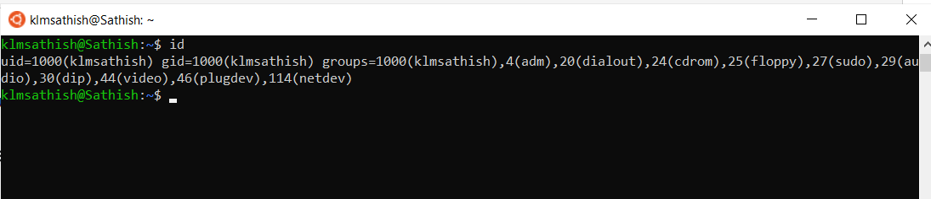

**id**

**ID command is used in Linux to print real and effective User ID (UID) and Group ID (GID). An UID is a single identity for a user. While Group ID (GID) can consist of more than one UID.**

Report on Linux Commands

31/08/2020

### SRi RAMACHANDRA

### ENGINEERINg &

### TEchnology

## OPERATING SYSTEMS

# COMMAND 14

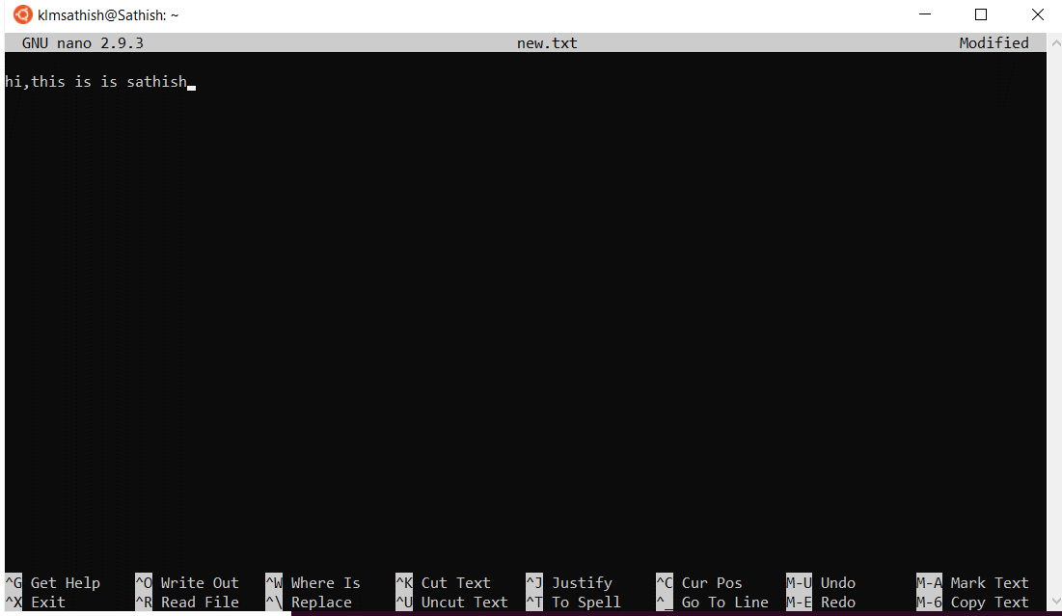

SRET

31/08/2020

Report on Linux Commands

**Nano**

**The nano command is a good text editor that denotes keywords with color and can recognize most languages.** **For example, if you need to make a new file named "check.txt", you can create it by using the command “nano check.txt”.**

### SRi RAMACHANDRA

### ENGINEERINg &

### TEchnology

## OPERATING SYSTEMS

# COMMAND 15

SRET

31/08/2020

Report on Linux Commands

**df**

**Use the df command to see the available disk space in each of the partitions in your system. You can just type in df in the command line and you can see each mounted partition and their used/available space in % and in KBs. If you want it shown in megabytes, you can use the command “df -m”.**

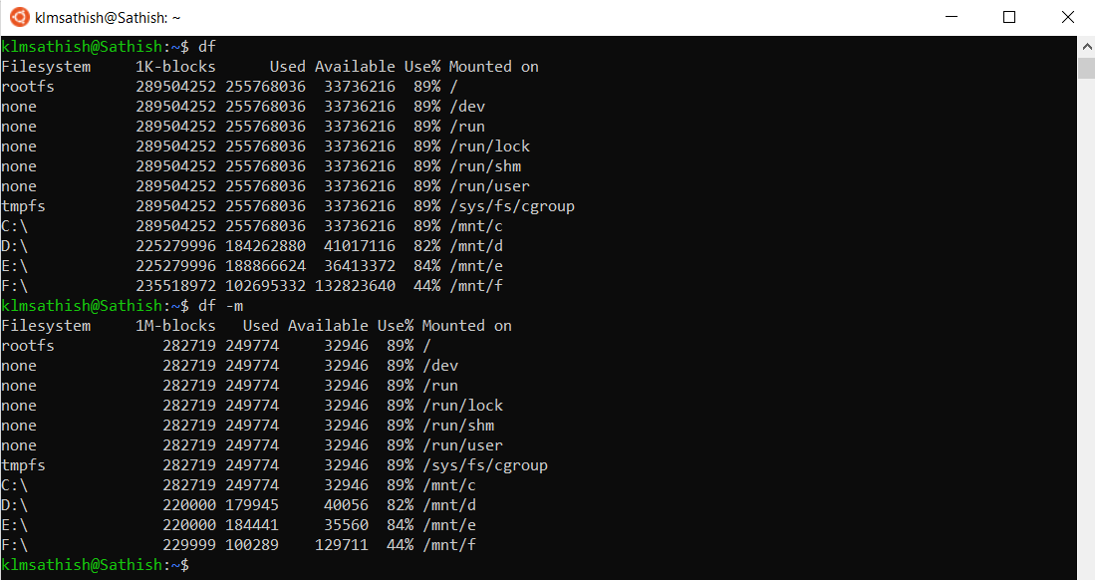

### SRi RAMACHANDRA

### ENGINEERINg &

### TEchnology

## OPERATING SYSTEMS

# COMMAND 16

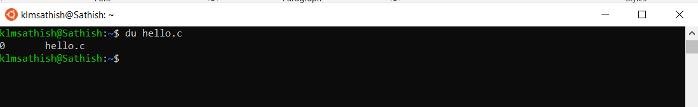

SRET

31/08/2020

Report on Linux Commands

**du**

**Use du to know the disk usage of a file in your system. If you want to know the disk usage for a particular folder or file in Linux, you can type in the command df and the name of the folder or file.**

### SRi RAMACHANDRA

### ENGINEERINg &

### TEchnology

## OPERATING SYSTEMS

# COMMAND 17

31/08/2020

Report on Linux Commands

SRET

**ping**

**Use ping to check your connection to a server.** **Simply, when you type in, for example, “ping google.com”, it checks if it can connect to the server and come back.**

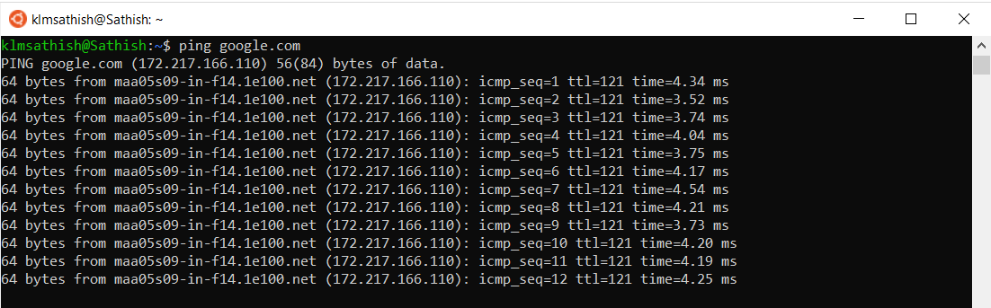

# COMMAND 18

**Useradd**

**Linux and Unix-like operating systems, the most common command to create users is 'useradd' or.**

SRET

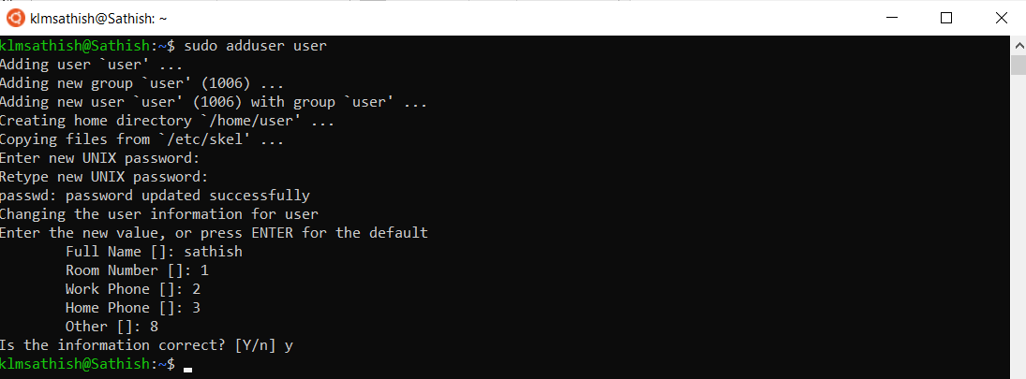

Report on Linux Commands

31/08/2020

### SRi RAMACHANDRA

### ENGINEERINg &

### TEchnology

## OPERATING SYSTEMS

# COMMAND 19

SRET

31/08/2020

Report on Linux Commands

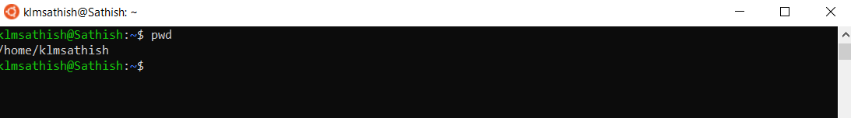

**pwd**

**Linux pwd is a command to print the name of the current working directory. When we are 'lost' into a deep directory, we can always reveal where we are.**

**From the following command we can understand that the system is up and running for the last 13 mins.**

### SRi RAMACHANDRA

### ENGINEERINg &

### TEchnology

## OPERATING SYSTEMS

### SRi RAMACHANDRA

### ENGINEERINg &

### TEchnology

## OPERATING SYSTEMS

# COMMAND 20

**tail**

**As you may know, cat command is used in displaying the entire content of a file via standard input. But in some cases, we have to print part of the file. By default, the tail command displays the last ten lines.**

**As an example, by using 'date +%D' you can view the date in 'MM/DD/YY' format.**

SRET

31/08/2020

Report on Linux Commands

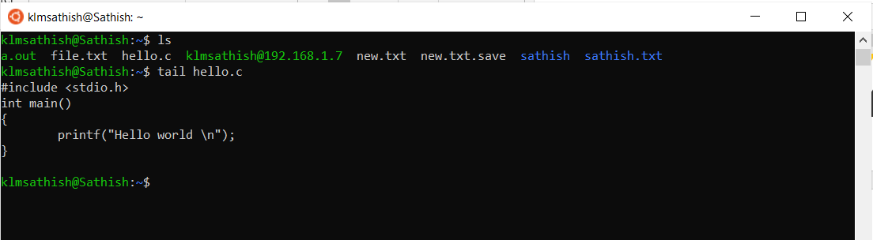

### SRi RAMACHANDRA

### ENGINEERINg &

### TEchnology

## OPERATING SYSTEMS

# COMMAND 21

SRET

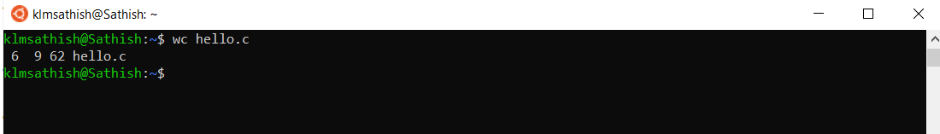

**wc**

**Linux wc command counts the number of bytes, characters, words, and lines in a file or in standard input.**

Report on Linux Commands

31/08/2020

### SRi RAMACHANDRA

### ENGINEERINg &

### TEchnology

## OPERATING SYSTEMS

# COMMAND 22

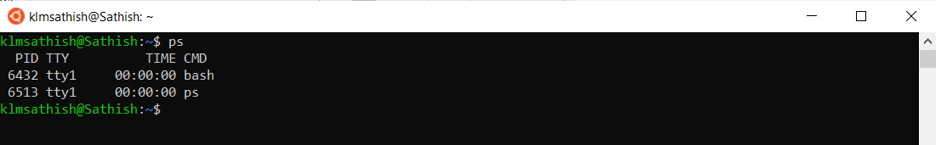

SRET

**ps**

**Linux ps command is a built-in tool to capture current processes on the system. It will capture the system condition at a single time.**

31/08/2020

Report on Linux Commands

### SRi RAMACHANDRA

### ENGINEERINg &

### TEchnology

## OPERATING SYSTEMS

# COMMAND 23

**top**

**The top command in Linux displays the running processes on the system. It is used extensively for monitoring the load on a server.**

SRET

31/08/2020

Report on Linux Commands

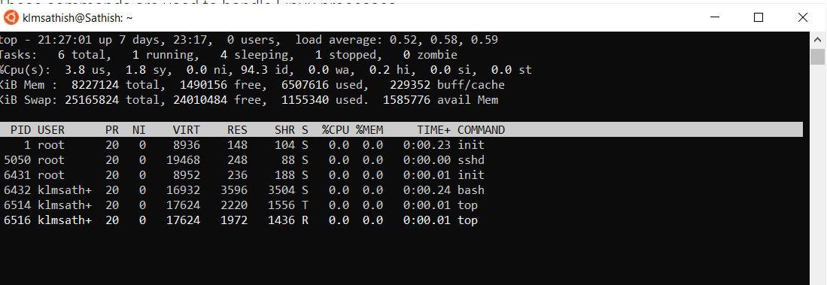

### SRi RAMACHANDRA

### ENGINEERINg &

### TEchnology

## OPERATING SYSTEMS

# COMMAND 24

SRET

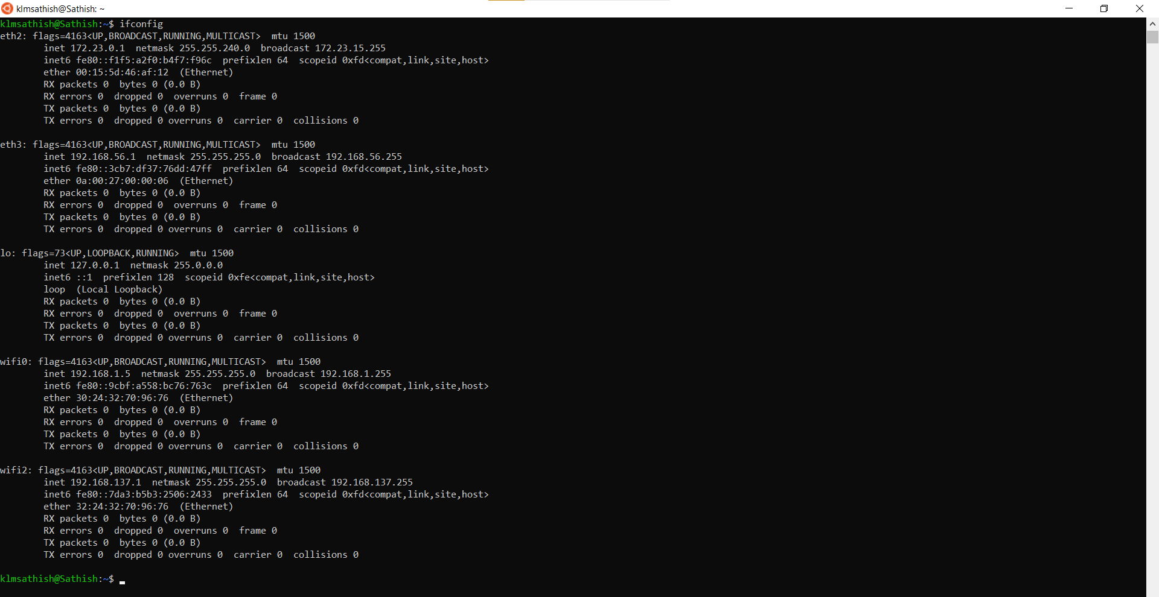

31/08/2020

Report on Linux Commands

**ifconfig**

**The ifconfig command is used to display and set ip address to network interfaces in Linux. Now ifconfig is deprecated in favor of iproute2 (the ip command).**

### SRi RAMACHANDRA

### ENGINEERINg &

### TEchnology

## OPERATING SYSTEMS

# COMMAND 25

31/08/2020

Report on Linux Commands

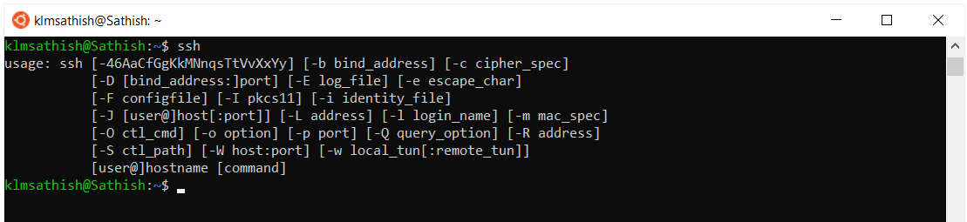

**ssh**

**SSH is used for logging into a remote machine and for executing commands on a remote machine. Whenever data is sent by a computer to the network, ssh will automatically encrypt.**

SRET

# COMMAND 26

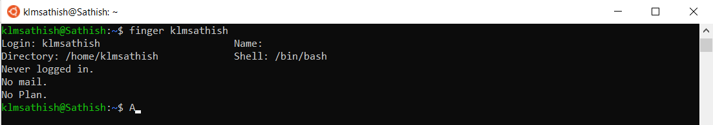

SRET

## **finger Command**

**The finger command is leveraged by programmers to look up and obtain brief information on users. It presents various data such as full name of the user account, real name, latest login information, idle time, write status, office location, and user’s home directory.**

Report on Linux Commands

31/08/2020

### SRi RAMACHANDRA

### ENGINEERINg &

### TEchnology

## OPERATING SYSTEMS

# COMMAND 27

SRET

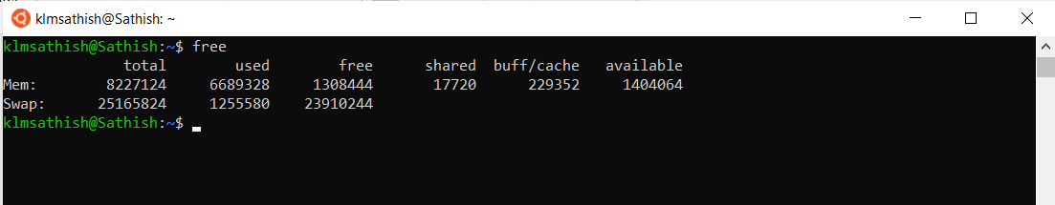

## **free Command**

**The free command-line utility provides users with a summary of the total available free space on the computer. More so, it also displays the total amount of used memory of the Random Access Memory (RAM) and the swap memory on the computer. Using the free command will also present the buffers leveraged by the kernel.**

**From the following command we can understand that the system is up and running for the last 13 mins.**

31/08/2020

Report on Linux Commands

### SRi RAMACHANDRA

### ENGINEERINg &

### TEchnology

## OPERATING SYSTEMS

### SRi RAMACHANDRA

### ENGINEERINg &

### TEchnology

## OPERATING SYSTEMS

# COMMAND 28

SRET

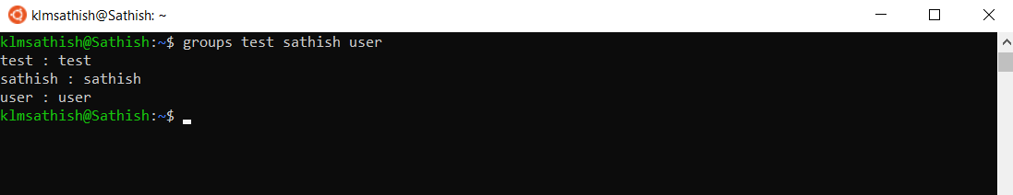

## **groups Command**

**Linux has to mechanism two manage users - users and groups. In simple words, the groups are a collection of users. A group makes it easier to manage user with same permission privileges.**

31/08/2020

Report on Linux Commands

### SRi RAMACHANDRA

### ENGINEERINg &

### TEchnology

## OPERATING SYSTEMS

# COMMAND 29

SRET

**history command**

**When you’ve been using Linux for a certain period of time, you’ll quickly notice that you can run hundreds of commands every day. As such, running history command is particularly useful if you want to review the commands you’ve entered before.**

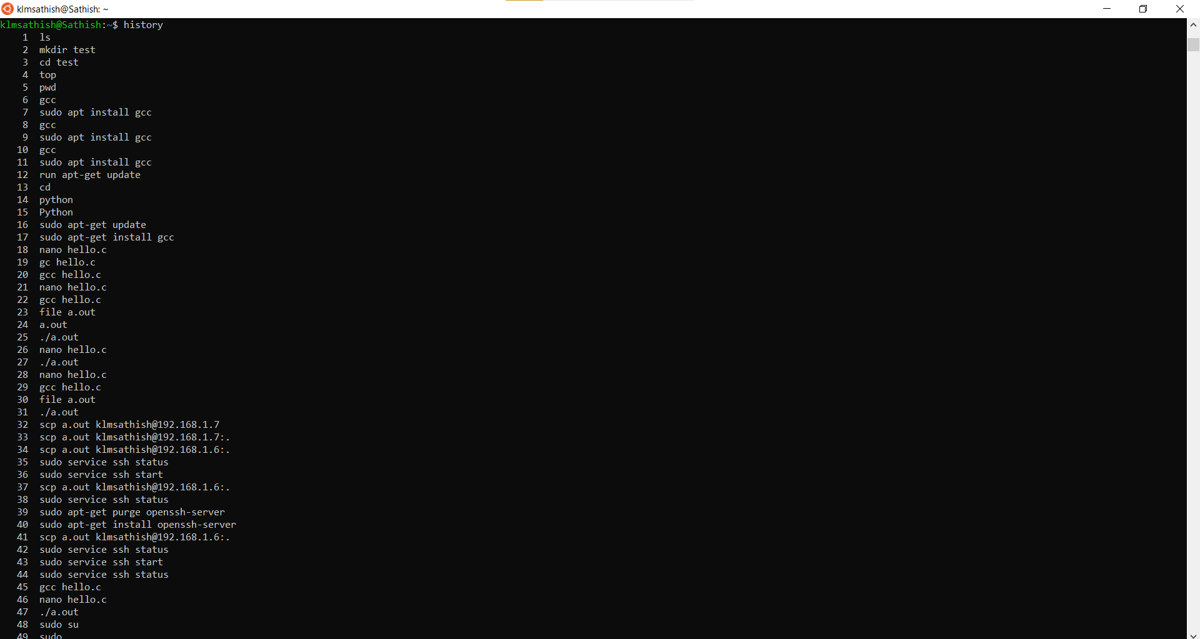

Report on Linux Commands

31/08/2020

### SRi RAMACHANDRA

### ENGINEERINg &

### TEchnology

## OPERATING SYSTEMS

# COMMAND 30

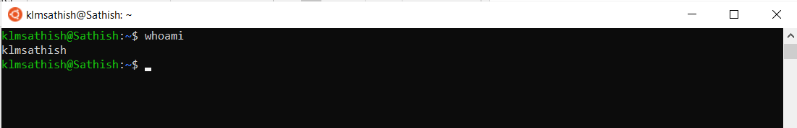

SRET

**whoami Command**

**The whoami command is simple and mostly comes handy for amateur Linux users. It tells the user with a username they are logged in as.**

31/08/2020

Report on Linux Commands

### SRi RAMACHANDRA

### ENGINEERINg &

### TEchnology

## OPERATING SYSTEMS

THANK YOU

